**Deliverable 3: Sprint #1**

**Team 14: /root**

Vincent Ho

Nanson Yuan Zan Zheng

Dimitar Stratiev

Kirishanth Ganeshamoorthy

Xibo Rao (Robbie)

***Table of Contents:***

1. **Project Planning**
   1. Updated Product Backlog………………………………………………………………………………………………. 1
   2. Updated Sprint Backlog and Spring Plan..………………………………………………………………………. 2
      1. Sprint Plan …..………………...……………………………………..…………………………………………. 2
      2. Sprint Backlog………………...……………………………………..…………………………………………. 2
   3. Updated Burndown Chart…………...……………………………………..…………………………………………. 2
   4. Task Board Snapshot…………………...……………………………………..…………………………………………. 3
      1. Beginning of the Week…...……………………………………..…………………………………………. 3
      2. Middle of the Week..……...……………………………………..…………………………………………. 3
      3. End of the Week..…………...……………………………………..…………………………………………. 4
2. **State of Project**
   1. Reasons for Changes.……..………………………………………………………………………………………………. 4
   2. Reasons for Lack of Progress…...…………………………………………………………………………………..4, 5

***Project Planning***

***Updated Product Backlog:***

1. As Natalie, a Historian, I want a button to create a new description field on custom forms so I can customize the descriptions for specific files

* Value: 10
* Cost: 55

2. As Natalie, a Historian, I want a button to delete existing description fields on forms so I can remove descriptions that are no longer relevant for my files

* Value: 10
* Cost: 10

3. As Natalie, a Historian, I want to save custom forms with new or modified description fields so I can have the same description fields for similar files

* Value: 10
* Cost: 40

4. As Natalie, a Historian, I want a button to modify existing description fields on forms so I can have more specific descriptions for my files

* Value: 9
* Cost: 10

5. As Natalie, a Historian, I want a checklist prompt to save changes across all identical files in all directories so my files are consistent

* Value: 8
* Cost: 35

6. As Natalie a Historian, I want to be able to rename all identical tags at once across all files and directories.

* Value: 7
* Cost: 10

7. As Natalie, a Historian Professor, I want to batch remove tags, so I can remove tags without having to manually delete them

* Value:6
* Cost: 10

8. As Natalie, an organized Historian, I want a button which combines existing tags together so I can have more general tags without having to create a new tag

* Value: 5
* Cost: 20

9. As Natalie, a Historian, I want a GUI for modifying or creating citation styles so I can use specific citations that suit the documents I am saving

* Value: 3
* Cost: 55

***Updated Spring Backlog and Sprint Plan:***

Sprint Plan

**1 Story Point = 1 Developer Hour**

**Spike #1**: Learn Zotero’s field system – SP: 15

**Spike #2:** Learn JavaScript – SP: 17

**Task #1:** Implement a remove button on Zotero’s default field window – SP: 15

**Task #2:** Implement an add button on Zotero’s default field window – SP: 1

**Task #3:** Implement a modify button on Zotero’s default field window – SP: 1

**Task #4:** Implement a save button on Zotero’s default field window – SP: 1

**Task #5:** Implement a function to search for existing field data in local Zotero database – SP: 30

**Task #6:** Implement a function to insert custom fields into local Zotero database - SP: 2

**Task #7:** Implement a function to modify existing field data into local Zotero database - SP: 2

**Task #8**: Implement a function to delete existing field data in local Zotero database - SP: 2

**Task #9:** Implement file I/O to save custom forms – SP: 10

**Task #10:** documentation of functions – SP: 2

Sprint Backlog

**Please refer to “Sprint #1 – Sprint Backlog.xlsx” for updated (and previous) Spring Backlog**

***Updated Burndown Chart:***

**Task Board Snapshot**

Beginning of the Week:

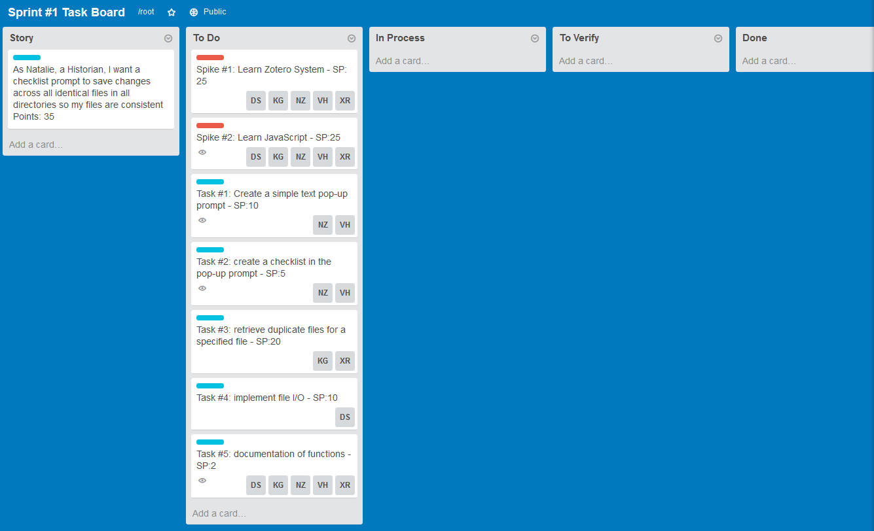

Middle of the Week:

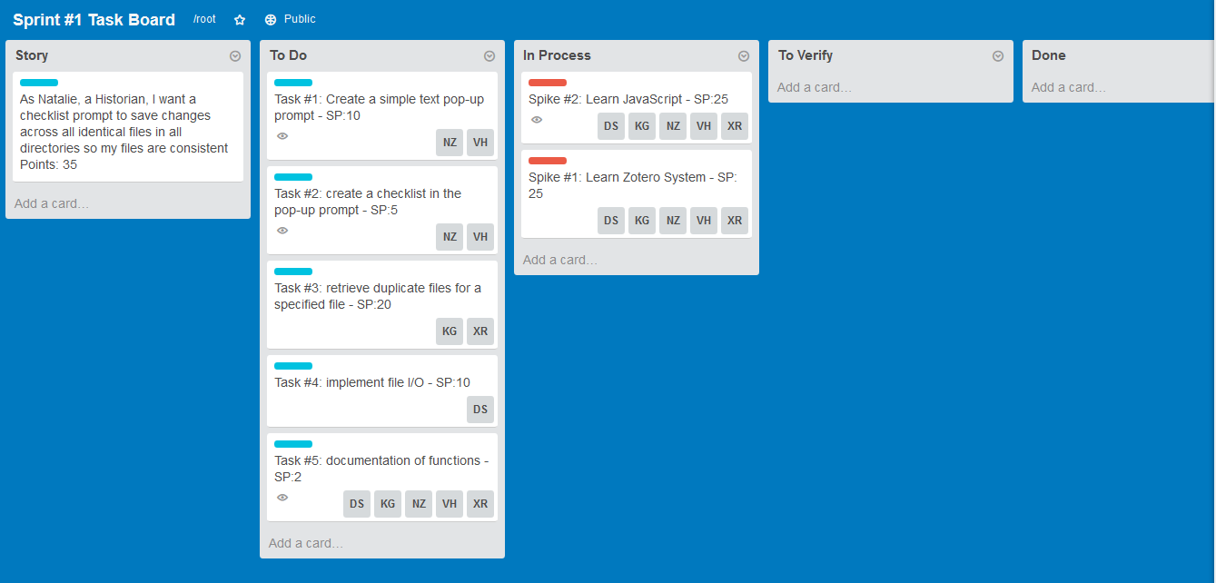

End of the Week:

**State of Project**

***Reasons for Changes:***

We held an emergency meeting on Saturday October 24th and decided to shift our priorities in user stories. We changed our sprint plans due to difficulty in installing our plugin on Zotero Standalone (incompatibility issues). It took longer than expected to get it working, so we decided to change priorities from our original plan of making two features by the last sprint to completing Natalie’s top priority of custom forms (User Story 3a, 3b, 3c, and 3d). If we have enough time after implementing the custom forms, we will implement her second most wanted feature of duplicate replacement.

Product backlog was also changed due to us learning Natalie’s priorities: what we thought was unimportant turned out to be her top priority. We adjusted our sprint plans and backlogs accordingly, due to lack of progress and potential infeasibility.

***Reason for lack of progress:***

**Note:** The plugin as of Friday 23rd does not have any working functionality, most of the time was spent trying to get the plugin to install properly.

**Wednesday October 14 (Day 3):**

*Vincent* –CSCD27 assignment due on this day

*Dimitar* -CSCD27 assignment due on this day

**Monday October 19th (Day 6):**

*Vincent* - needed to study for Exam on Wednesday October 21st

**Tuesday October 20th (Day 7):**

*Dimitar* - studying for an exam on October 21st

**Wednesday October 21st (Day 8):**

*Dimitar* - at school the entire day + evening exam

*Vincent* - Class until 9, also had MGMC30 exam

**Thursday October 22nd (Day 9):**

*Vincent* - Working on assignments from other class

**Saturday October 24 (day 11):**

*Vincent* - Working on assignment from CSCD03 (took the whole day)

**Sunday October 25 (day 12):**

*Vincent* – Studying for MGHB12 exam on Monday October 26